**React-Auth0-App:**

**Setup Frontend (React)**

1. Navigate to the frontend directory:

***cd ../frontend***

2. Install the dependencies:

***npm install***

***3.taking the Domain and Clientid:***

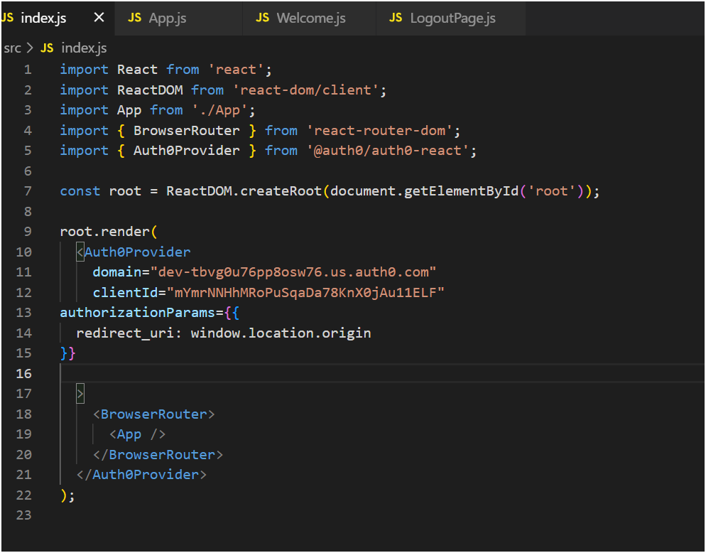

Taking from Auth 0:

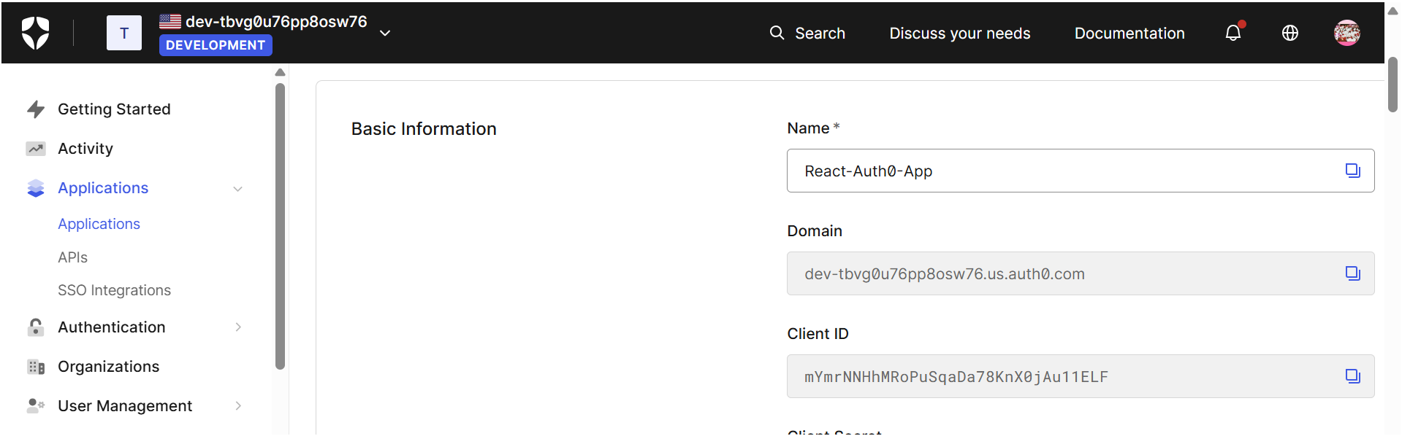

4. Start the React development server:

***npm start***

**Step 4: Usage**

1. Open http://localhost:3000 to access the frontend.  
2. Use the 'Login with Auth0' button to log in.  
3. After login, You can see the welcome with logout button.